**DAILY ONLINE ACTIVITIES SUMMARY**

|  |  |  |  |  |  |  |  |  |
| --- | --- | --- | --- | --- | --- | --- | --- | --- |
| **Date:** | **19/05/2020** | | | | | **Name:** | **Prashant Rama Bhat Kodlekere** | |
| **Sem & Sec** | **4th sem (B sec)** | | | | | **USN:** | **4AL18CS060** | |
| **Online Test Summary** | | | | | | | | |
| **Subject** | | **DESIEGN AND ANALYSIS OF ALGORITHMS (DAA)** | | | | | | |
| **Max. Marks** | | **30** | | **Score** | | | **15** | |
| **Certification Course Summary** | | | | | | | | |
| **Course** | **The python 3 course –learn python practically.** | | | | | | | |
| **Certificate Provider** | | | **Udemy** | | **Duration** | | | 1.5 hrs with activities(total 3 hrs) |
| **Coding Challenges** | | | | | | | | |
| **Problem Statement:** Write C program to check weather the string is the subsequence of the given string.  Top of Form  Bottom of Form | | | | | | | | |
| **Status:Completed** | | | | | | | | |
| **Uploaded the report in Github** | | | | | **YES** | | | |
| **If yes Repository name** | | | | | **https://github.com/prashantkodlekere/codingactivity** | | | |
| **Uploaded the report in slack** | | | | | **YES** | | | |

Online Test Details:

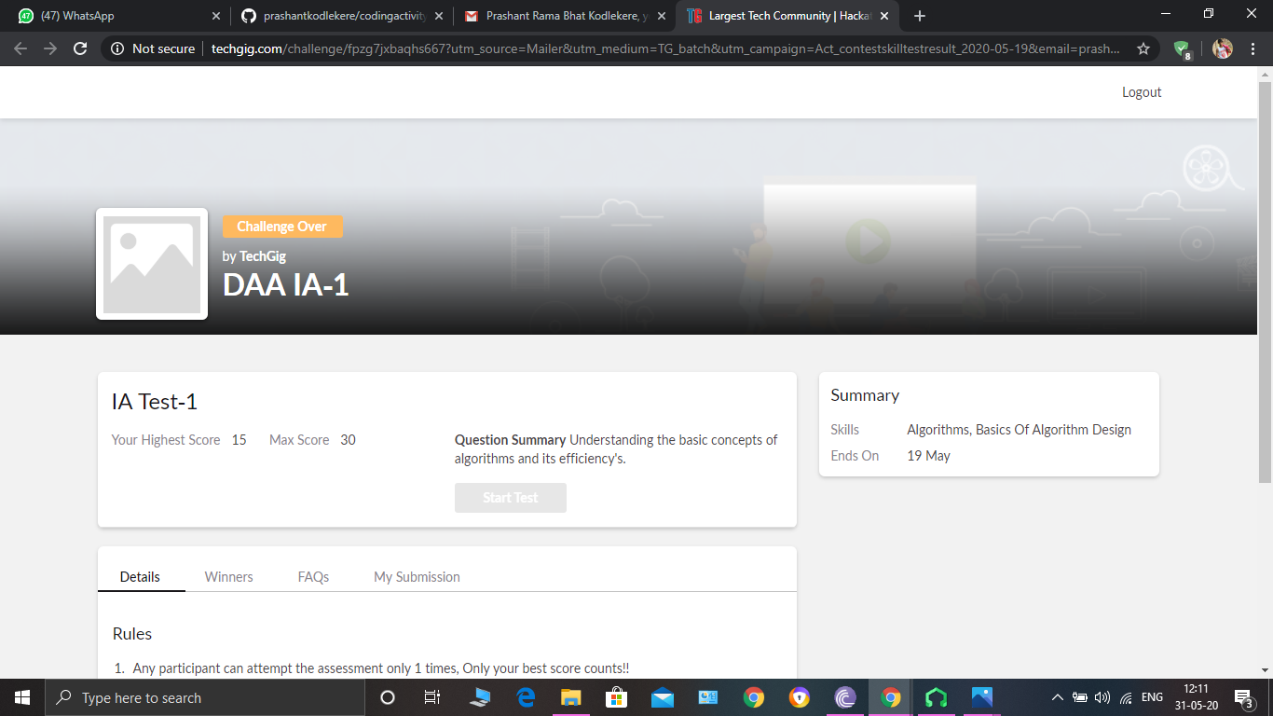

DESIEGN AND ANALYSIS OF ALGORITHMS Internals was conducted. A total of 30 questions were Multiple Choice Questions.

The above snapshot is the result sheet which was mailed to us by the Techgig team.

Certification Course Details:

Course name: **The python 3 course –learn python practically.**

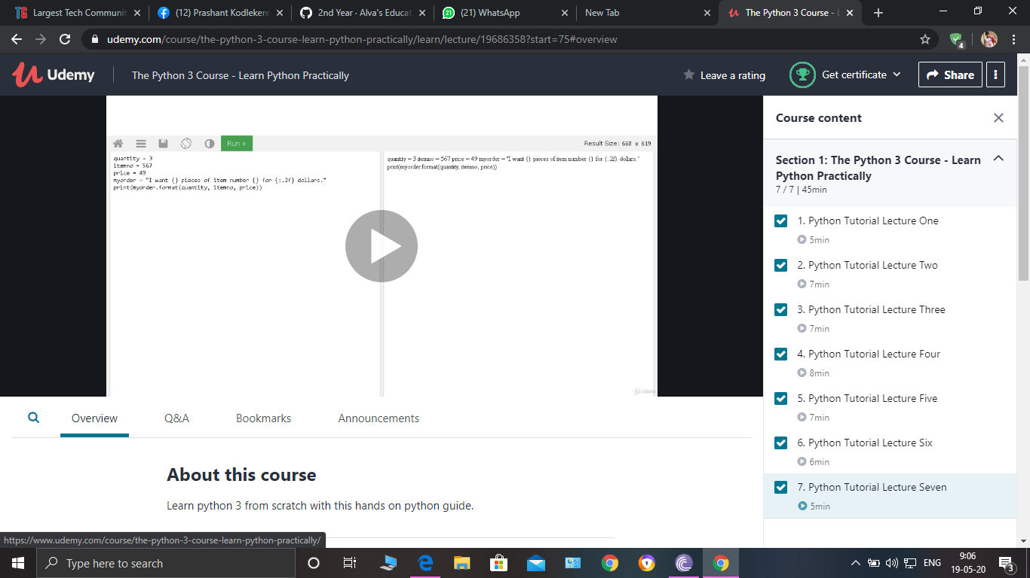

In this course, I have learnt the fundamentals of python3 through video lecturers,quizzes,and practice problems.

Coding Challenges Details:

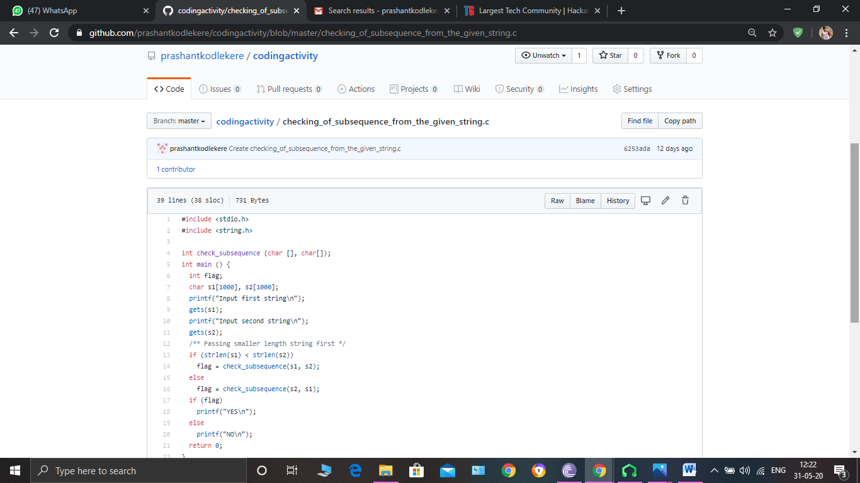

**The question I took to code is:**

Write C program to check weather the string is the subsequence of the given string.

Code: The above snapshot is the code which I have uploaded in my Github repository.